# **Name: Abdurrahman Qureshi**

# **Roll No: 210451**

Practical No: 9

1. **Sum of series of Hexadecimal numbers (8 bit).**

**OUTPUT:** 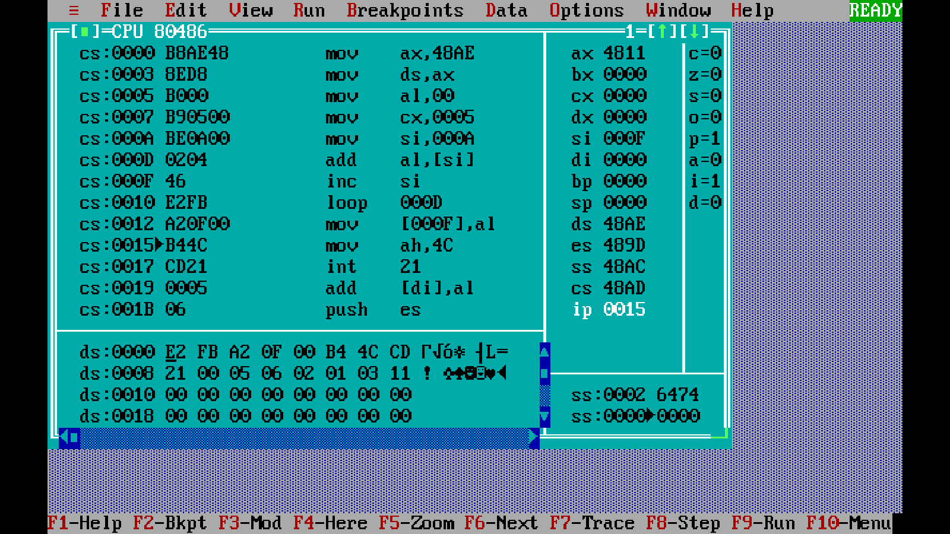

**2) Sum of series of Hexadecimal numbers (16 bit).**

**OUTPUT:** 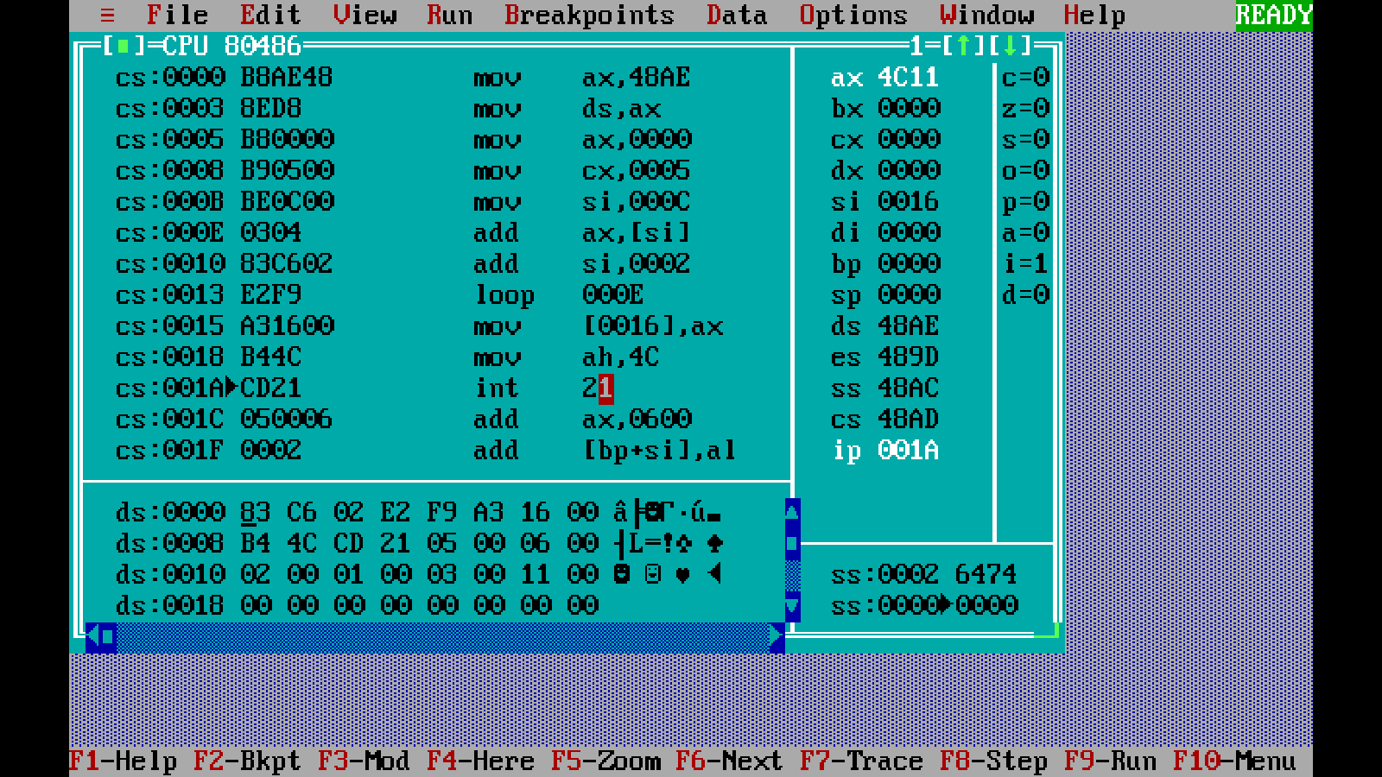

**3) Sum of series of BCD**

**OUTPUT:**

